SoDaDa Visual Resource

This visual resource is for people coming to SoDaDa on Monday 16 March 2020. It has information and pictures to prepare you for your visit.

If you have questions, please call or email Ella at Club Soda

Phone: 07309 750283
Email: ella@clubsoda.org.uk

SoDaDa is an event showcasing:
- Performances from DISCO DISCO
- Dance from SLiDE
- Visual art from MOSS
- Music from Soda Crew DJs

Where is SoDaDa?

SoDaDa is at FunHouse. This is the outside of FunHouse, the main entrance is on the right. There is level access into the building.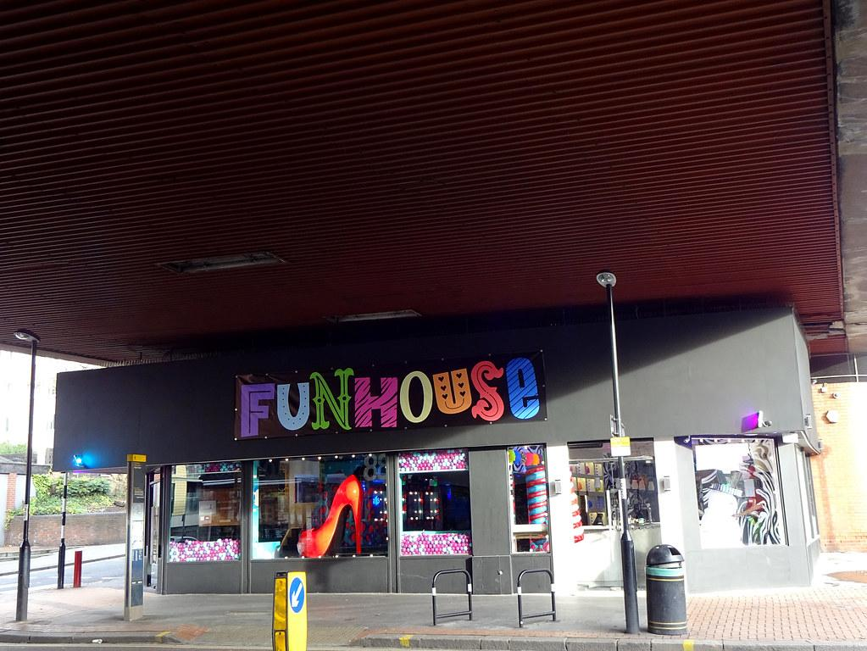Getting here:

You can get to FunHouse a few different ways. You can:

- Take a train to East Croydon station and then walk about 10-15 minutes
- Take a train to West Croydon station and then walk about 15-20 minutes
- Take the bus. The 60, 166, 312, 405, 407, 412, 455, 466 and N68 all stop at Croydon flyover bus stop close to FunHouse
- Cycle. There are bike rails to chain your bike right outside FunHouse
- Drive. The closest car park is NCP Car Park Croydon on Wandle Road

When is SoDaDa?

SoDaDa will start at 7pm

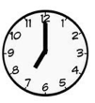

What will happen at SoDaDa?

SoDaDa is a party and club night. People will laugh and talk. There will be performances, music and dancing.

The whole event is relaxed. This means you can move and make noise. You can leave and come back whenever you want to.

You will start at the main entrance. There will be security people at the door who may ask for ID and to check your bags.

Someone from Club Soda in a yellow Club Soda Marshal t-shirt will say hello and ask you to buy a ticket. Tickets are £5. There is a suggested donation of £2 for support workers. You will be given a paper ticket.

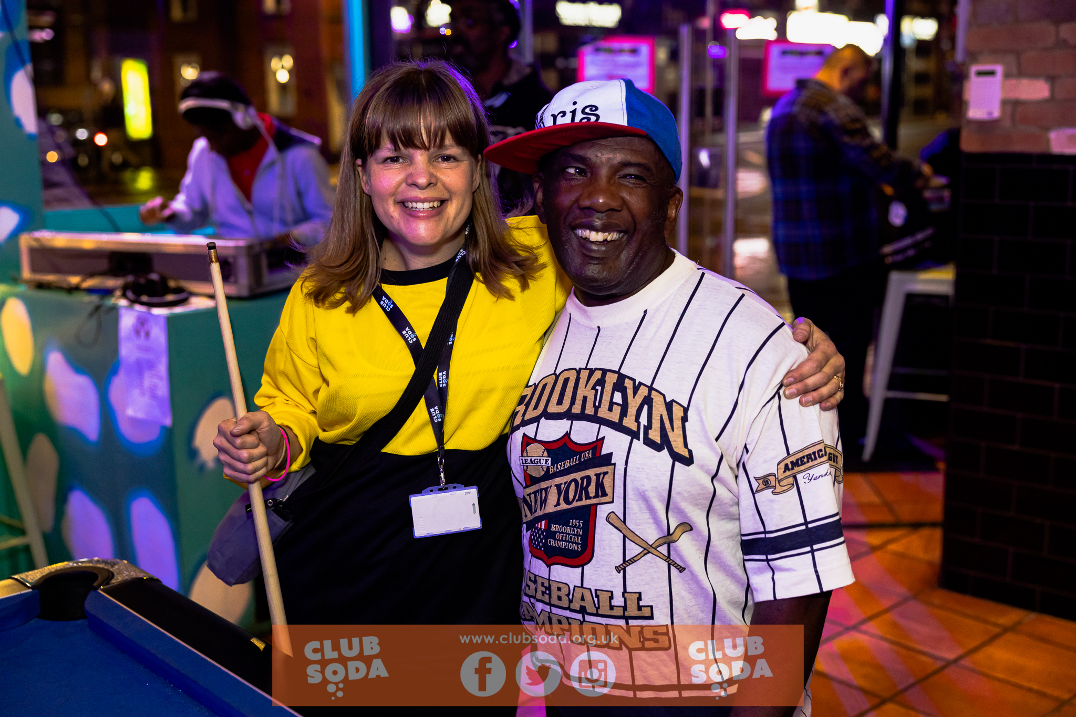

If you have any problems or questions on the night, you can ask anyone in a yellow Club Soda Marshal t-shirt. They are here to help!

You will then be able to explore FunHouse. There are three rooms that you can go in and out of whenever you like.

In the bar room there is a bar where you can buy drinks. You will be able to sit in seats wherever you like.

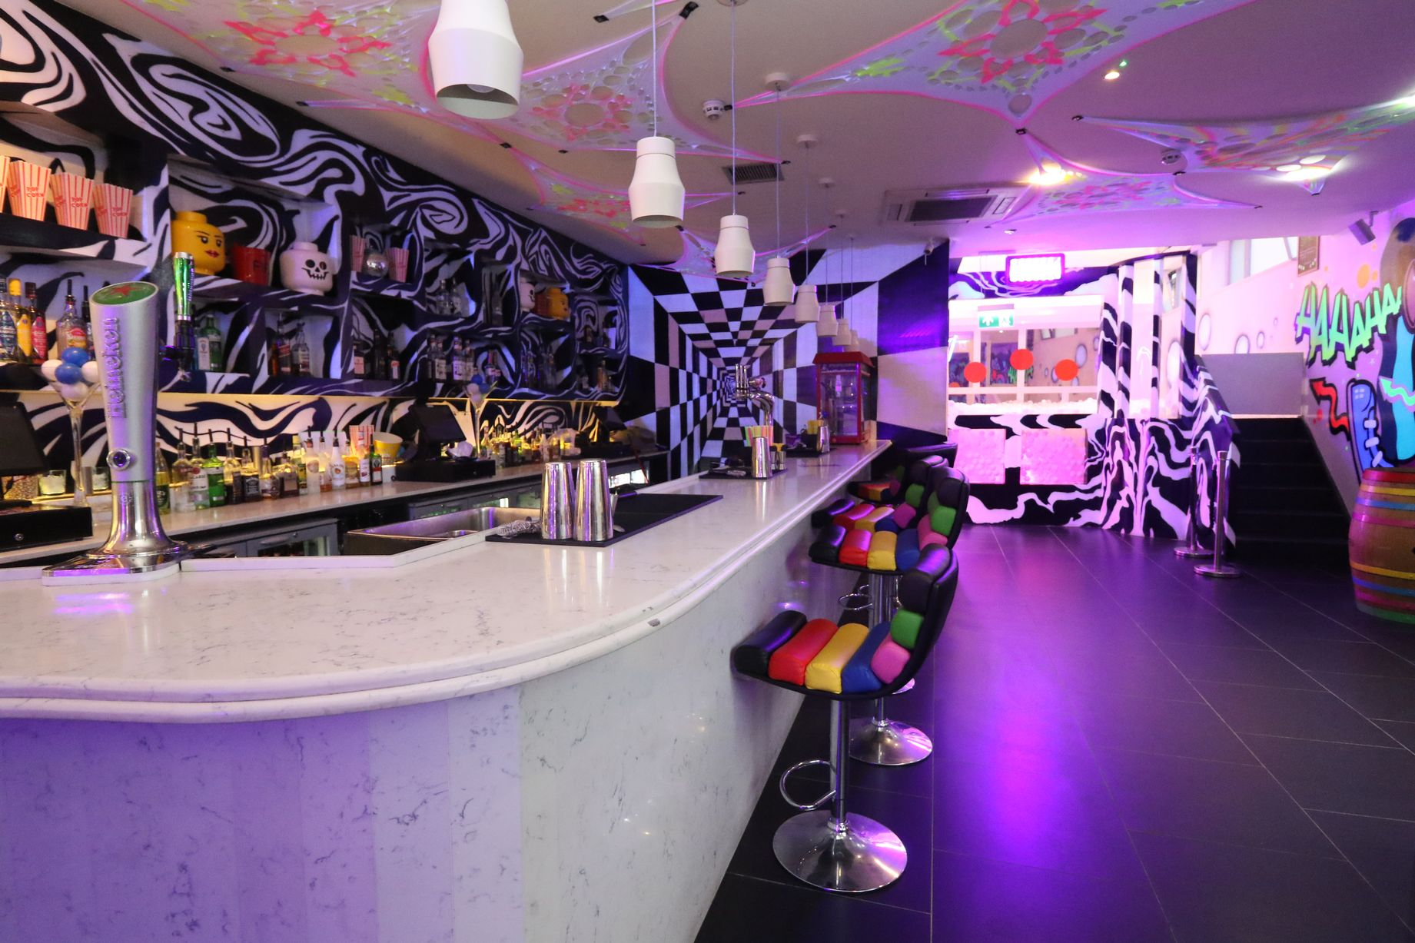

In the dance floor room, there is also a bar where you can buy drinks. You will be able to sit in seats wherever you like.

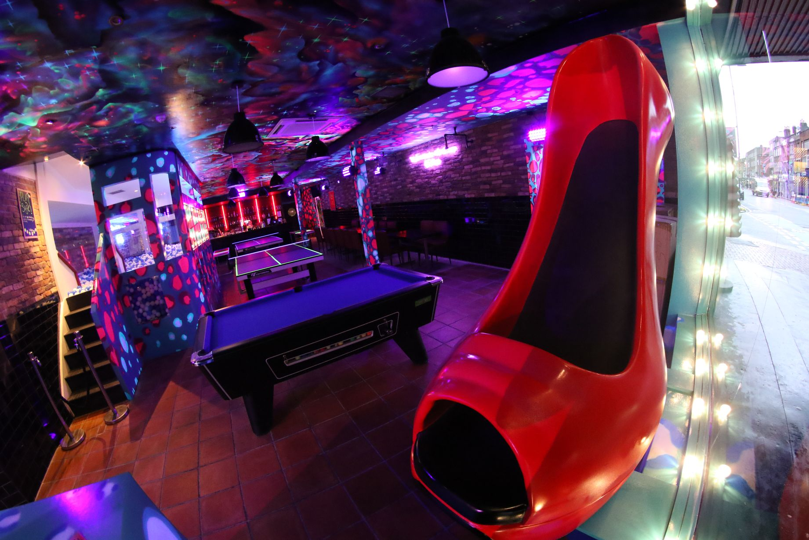

DJs will be playing music for the whole event, you can listen in the bar room and the dance floor room. There is plenty of room for dancing in the dance floor room and you can dance whenever you like.

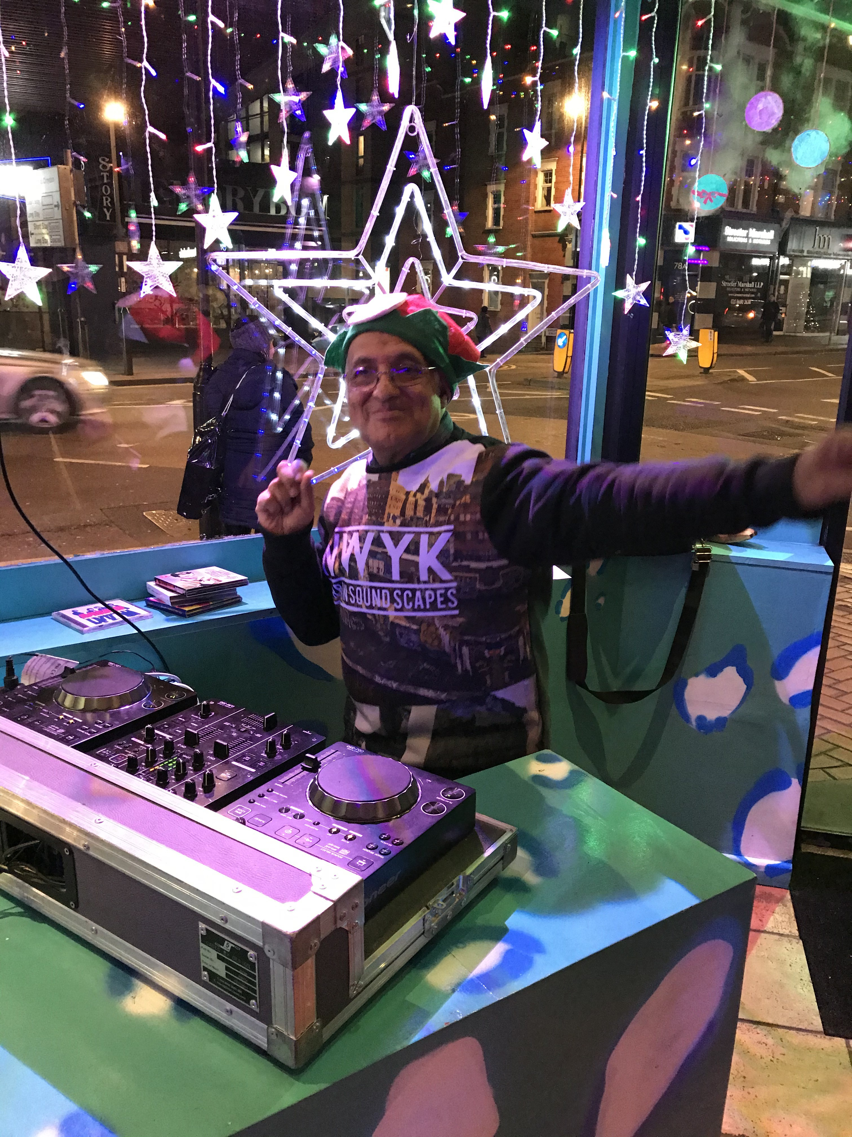

DISCO DISCO are a theatre group who will be doing short performances in the dance floor room. They will be silent and some will be wearing white masks.
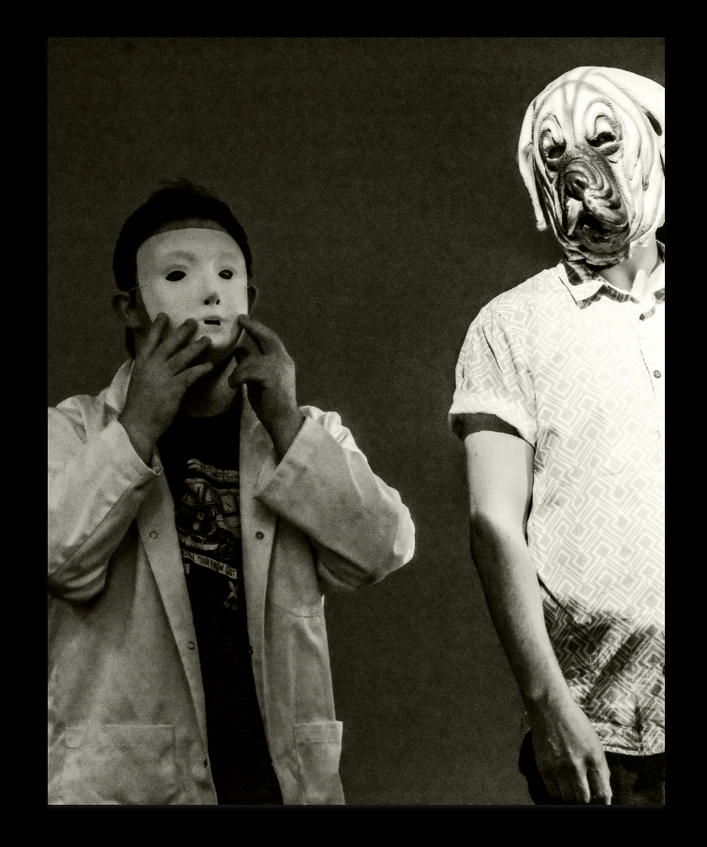

SLiDE are a dance group who will be doing short dances in the dance floor room. They will be in shiny clothes and dance with a disco ball.
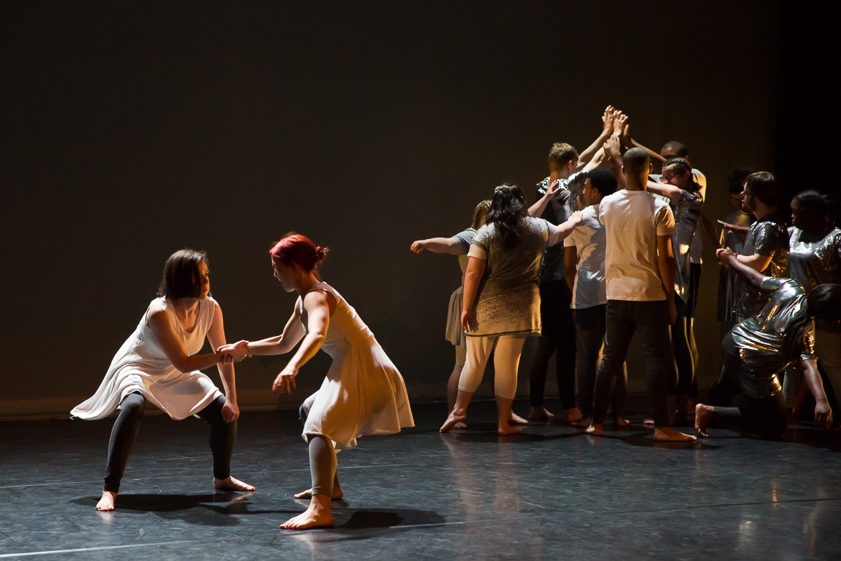

At the back of the dance floor room there are accessible, gender neutral toilets.

To the back of the building is a third room called the chill-out space. There are two steps to get into this room. Please let someone in a yellow Club Soda Marshal t-shirt if you need a step free route into the chill-out space.

The chill-out space will be much quieter. If you need a break from whatever you’re doing you can go to the chill-out space. You will be able to sit wherever you like. Ear defenders will be available in the chill-out space if you require them at any point.

The party will end at 10.00pm

