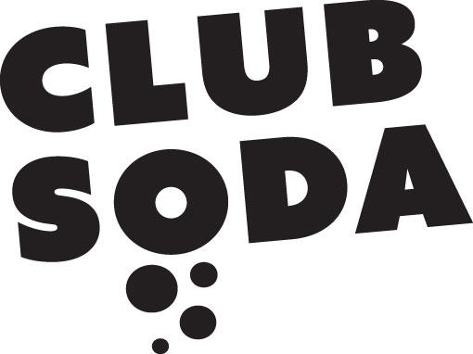

Club Soda
Project Manager

Information Pack

General Information

Who?
We are a group of adults with learning disabilities and we are creating exciting social and creative opportunities in Croydon for ourselves and for other people. We are creating exciting social and creative opportunities in Croydon for ourselves and for other people.

Pioneers
We were the first to provide accessible club nights in mainstream Croydon venues.

Artists and creatives
We produce new and original art, by collaborating with musicians, DJs, actors, film-makers, fine artists, photographers and many others. We support and encourage learning disabled artists.

Communicators and campaigners
We help to promote a better understanding of people with learning disabilities. We’re working towards a more inclusive, accessible, and fairer Croydon.

Friendly, ambitious, supportive, proud, experimental, forward-looking, welcoming – and successful!

Club Soda is made up of:
- 6 committee members who make all the important decisions
- 40 members who attend weekly workshops and projects
- 12 volunteers
- 300+ people who attend our regular programme of events

Most have a learning disability or difficulty, and some may also have a mental health condition. We also employ freelance artists and creatives to help us with projects.

We formed in 2009 with the help of Croydon Council and in 2019 we became a registered charity. We are supported by a part-time member of staff from the Council.

What, Why, How

Our vision – the world we want to see
We want Croydon to be a place where people with learning disabilities are as happy, social, creative and valued as everyone else.

Our mission – how we’re achieving this
Club Soda’s mission is to create opportunities and change perceptions. We create opportunities for people with learning disabilities to be happy and social, creative and productive. And we change perceptions about people with learning disabilities, and about Croydon.
We do this through social and creative activities which empower and excite us, and which include weekly workshops in DJing and music making.
Background to Club Soda

In 2009 a team of volunteers with learning disabilities created Club Soda which ran quarterly club nights at the Croydon Clocktower for large audiences of 300+ people. The success of the events led to the establishment of further groups, projects and regular workshops, including a theatre company and a collective of artists. In 2012 Croydon based nightclub the Bad Apple was one of the first music venues to invite Club Soda to take up residency at the club and then in 2013, Soda Beat was established for musicians with learning disabilities. In 2014, Club Soda became a constituted group in part to give themselves more autonomy to work outside of the local authority, but also to enable the members to have more control over decision making within the organisation.
Club Soda’s popularity as the producer of learning disability arts events, including integrated gigs, theatre performances and art exhibitions, rose in South London. Several music venues and event organisers came forward to support the music and performance events. More recently Hoodoos, a music and event organiser, has supported and partnered Club Soda in performances, music events and raised funds for the organisation as well. Hoodoos, their local music event partner has agreed to co-house Club Soda in their new music venue, scheduled for completion in 2021.
Within the activities of Club Soda, it is the ownership of the music and the creativity that comes from artists with learning disabilities that is so visceral and which significantly impacts non-disabled people who enter this space. The Soda Beat bands, Soda Jam evening music sessions, the monthly Club Nights and Soda Crew DJ’s have positively, directly impacted the lives of thousands of people locally and within the neighbouring boroughs, as evidenced in the attendance numbers at these events and in the increasing requests to join the tutored workshops.
In 2017, Club Soda was one of 10 organisations across the UK and the only organisation in London, chosen by the charity, Stay Up Late, to launch a local Gig Buddies project. Gig Buddies Croydon benefits people with learning disabilities and/or autism, where someone with a learning disability is paired with a volunteer buddy, to become friends and attend mutually interesting events, together. After a successful pilot scheme in 2017, Club Soda received a 3-year grant for this project in 2019, from the National Lottery Community Fund.

Club Soda: Project Manager

Attached is a job description for the post of Project Manager.

The Project Manager will be employed by Club Soda on a one year contract initially, with the possibility to extend subject to successful funding bids.
The post is for 21 hours per week, the work pattern is negotiable.
The salary is £30,550 (full-time equivalent 36hrs full-time) pro rata paid monthly in arrears.
You will be entitled to 17 days annual leave per year (includes Bank Holidays).

The successful candidate will be subject to an Enhanced DBS check.

To apply please complete the application form (link on our website) and submit your 60 second video to tell us why you’d be great at the job.

(Details of how to send the video to us are in the application form).

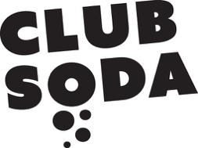
JOB DESCRIPTION

JOB TITLE: Project Manager (Club Soda)

ACCOUNTABLE TO: The Director

OVERALL PURPOSE OF THE JOB

To manage Club Soda’s special projects and live events programme.

KEY RESPONSIBILITIES

- To oversee the delivery of all Club Soda projects and live events (excluding Gig Buddies Croydon).

- To act as the main contact person for all Club Soda members (i.e. project participants) and audiences at our live events.

- To support the Director to deliver the charity’s business plan and ensure all its policies are relevant and up-to-date.

- To work alongside the charity’s trustees and ensure that the charity has a ‘user-run’ focus.

- To develop and deliver a marketing and audience development strategy for Club Soda which will improve our social media presence and make better use of our website to profile our work and achievements.

- To support the Director in reporting back to funders by gathering evidence on the impact of projects and events on participants, collaborating artists and audiences.

- To carry out risk assessments for projects and events.

- To manage relevant budgets and maintain financial records for auditing purposes. This will include keeping up-to-date, accurate, and factual records, using appropriate office systems and databases, ensuring confidentiality is maintained at all times.

- To maintain good practice in line with Club Soda policies and procedures, particularly relating to Equality & Diversity, Health & Safety and Green Impact issues.

- To promote the charity to users, relevant stakeholders and the community at large in person and through written materials i.e. press releases.

- To foster and develop professional links and good quality relations with statutory, and other agencies and the community at large. This will include raising awareness and understanding of Club Soda within the community, and the difficulties that those with learning disabilities face.

- To work as a team member sharing skills, and contributing to the smooth running and good reputation of the organisation.

- Undertake such other duties and tasks commensurate to the character of work. Therefore the above list of main tasks in this job description should not be regarded as exclusive or exhaustive.

Closing date for applications is 5pm on 29 November. Interviews will be held on Monday 9 December 2019.

Club Soda
Staff Structure

Board
of Trustees

Director

Project Manager (Gig Buddies)

Assistant Project Manager

Volunteers

4 x Freelance Music Tutors

Project Manager (Club Soda)

PERSON SPECIFICATION
Project Manager

Skills and Abilities
1. | Ability to communicate effectively with a wide range of people at all levels using a variety of methods
2. | Ability to organise own workload, be able to work under pressure and to work to deadlines
3. | Ability to set up and co-ordinate a community based project
4. | Ability to respect and promote a person’s right to make informed decisions/choice without influence
5. | Computer skills and competence using Microsoft Word and Excel
6. | skills in promoting projects in line with current social media trends and practices

Knowledge / Experience
1. | Proven experience of managing projects of similar complexity
2. | An understanding of the operation of the public, private and voluntary sector
3. | An understanding of discrimination and disability issues, and has experience of equal opportunities practice
4. | Knowledge of the purpose and practice of voluntary work
5. | Experience of organising and promoting events
6. | Experience of using digital platforms (Instagram, Facebook, Twitter)

Qualities
1. | A positive attitude towards the rights, independence, inclusion and choice for people with learning disabilities
2. | A keen interest in promoting projects in line with current social media trends and practices
3. | Able to work as part of a team, and to take responsibility for planning and completing your own work
4. | Commitment to the values of diversity and equality
5. | A self-motivated, committed, free thinker and innovator
6. | Community minded
Special Conditions
1. | Flexibility regarding hours; including evenings and weekends

